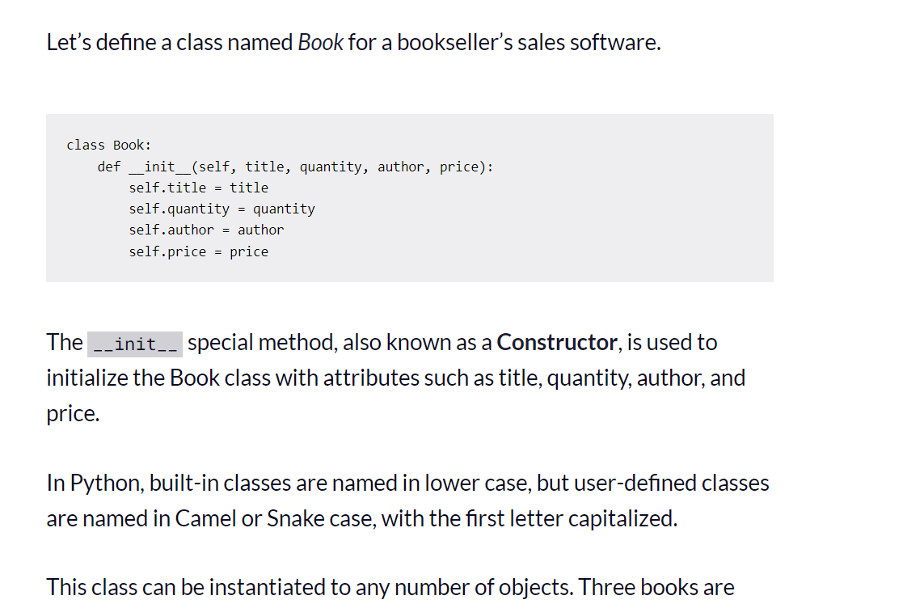

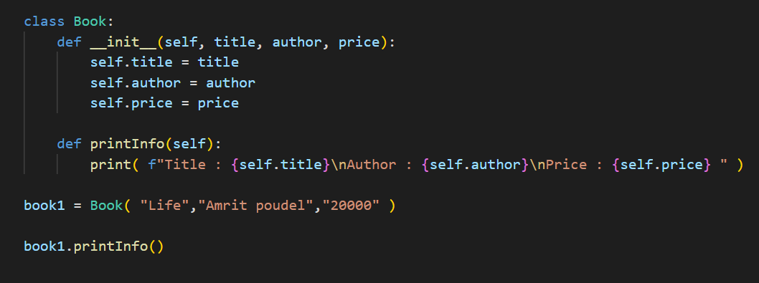

Here __init( )__ can be called a constructor

The double underscores can also be called dunder

This dunder init method can also be called special method in python

There are other special methods in python also

**Why we have certain function, starting with __ inside class in python?**

In Python, a special method is a defined function that starts and ends with two underscores and is invoked automatically when certain conditions are met.

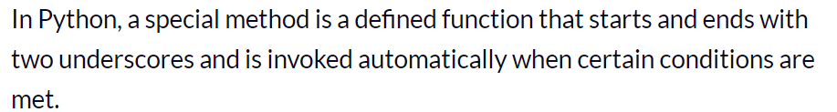

For a constructor such special condition to be called is when the object instantation happens

Encapsulation

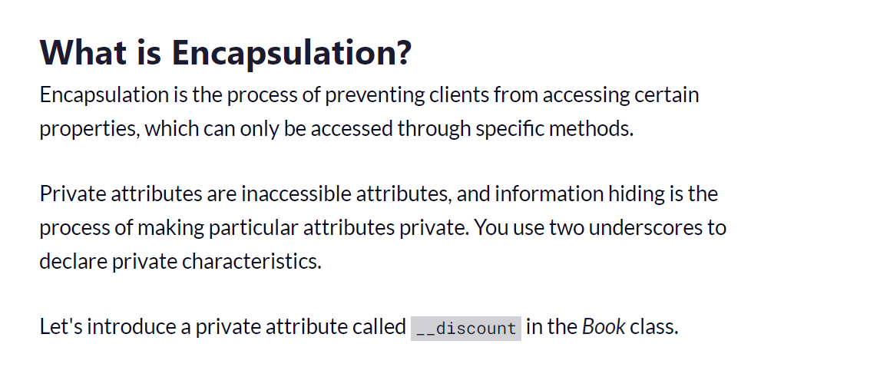

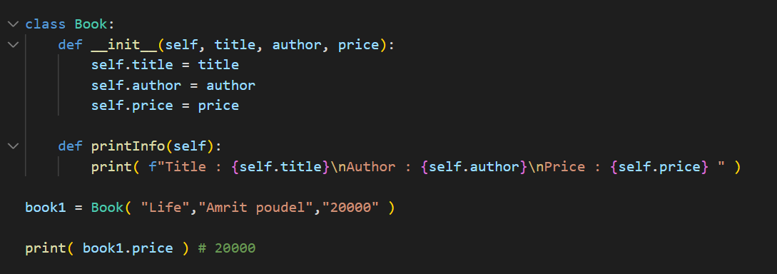

Here price is a public variable, it can be easily accessed from the outside also

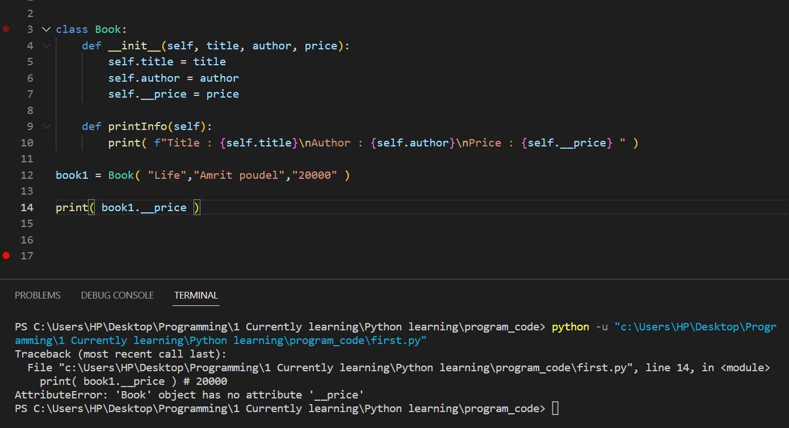

Now after using **__ in-front** of the variable the variable inside the class becomes **private variable,** now it can only be accessed via a method

**Inheritance**

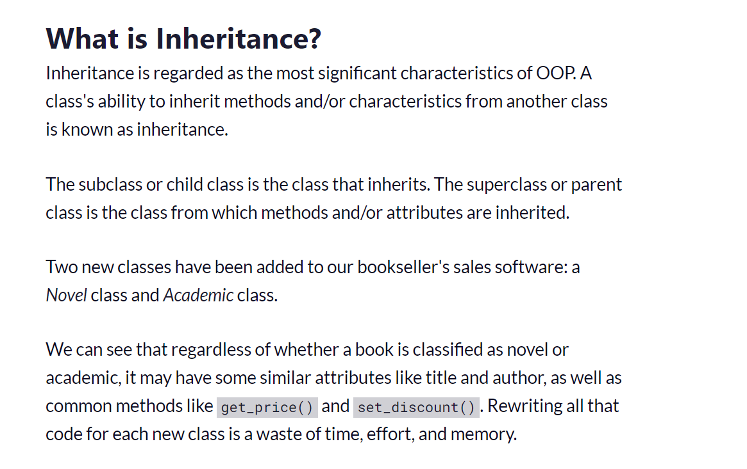

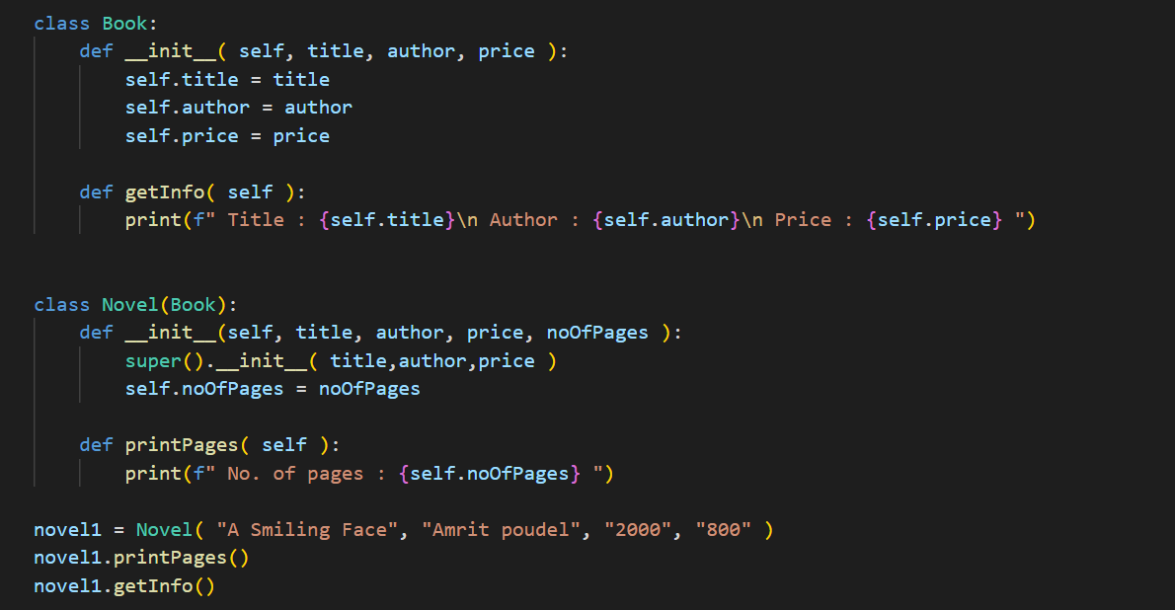

In this was we can do inheritance , we can inherit any useful methods from the parent class to child class

**Polymorphism**

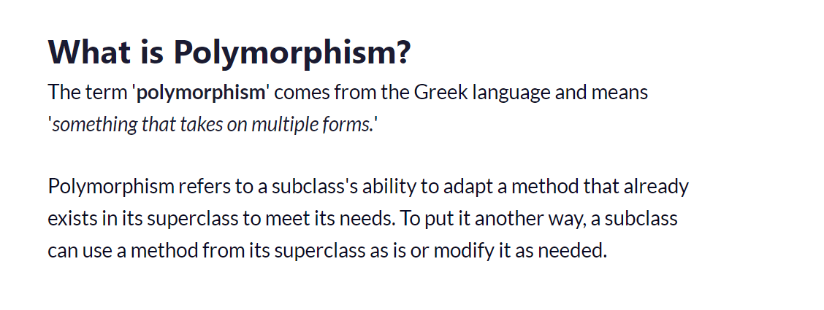

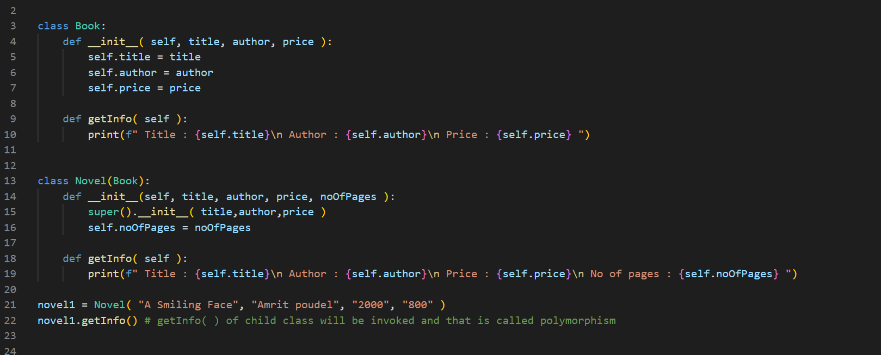

In python the child class can modify the function that is also present in the parent class and hence same function present on both classes but will be called by each classes object

**Method Overloading**

The concept of method overloading is found in almost every well-known programming language that follows object-oriented programming concepts. It simply refers to the use of many methods with the **same name** that take **various numbers of arguments** within a **single class**.

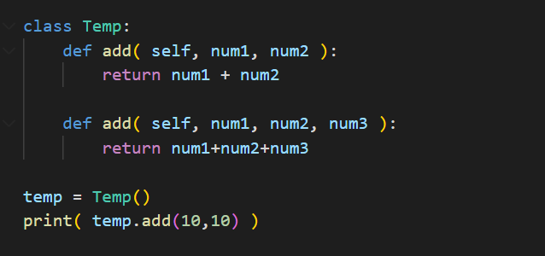

This gives error

Python **does not have** method overloading

Python remembers the **most recent definition** of the method

**Method Overriding**

When a method with the **same name and arguments** is used in both **a derived class and a parent or super** class, we say that the derived class method "overrides" the method provided in the parent class

As shown above

